Nama Peserta : Ricky Adiputra

No Peserta : 023

Tugas : ASSIGNMENT 2

Soal 1

**SELECT** * **FROM** customers c;

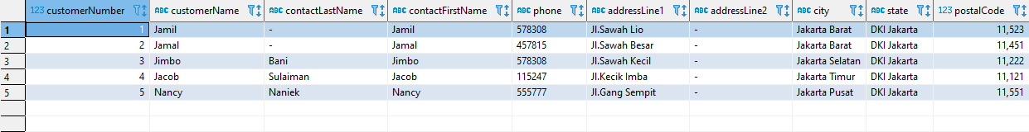

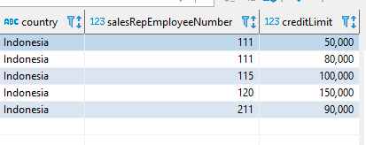

Soal 2

**SELECT** * **FROM** productlines;

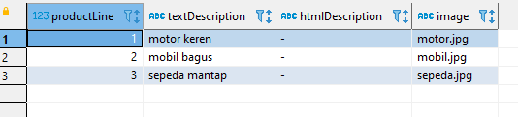

Soal 3

**SELECT** * **FROM** products;

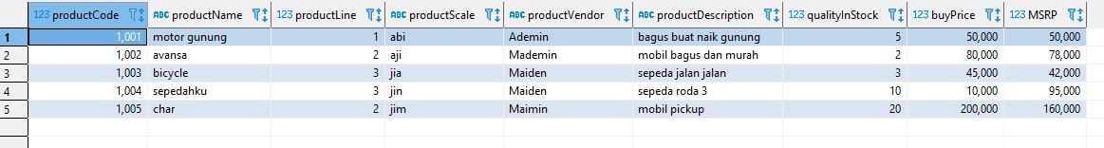

Soal 4

**SELECT** * **FROM** orders;

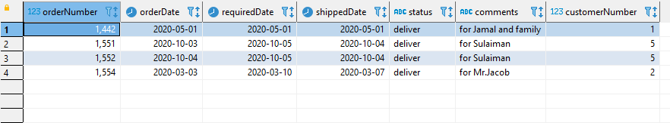

Soal 5

**SELECT** * **FROM** orderdetails;

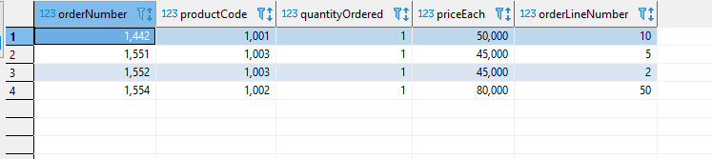

Soal 6

**SELECT** * **FROM** payments;

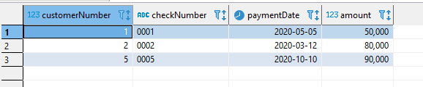

Soal 7

**SELECT** * **FROM** employees;

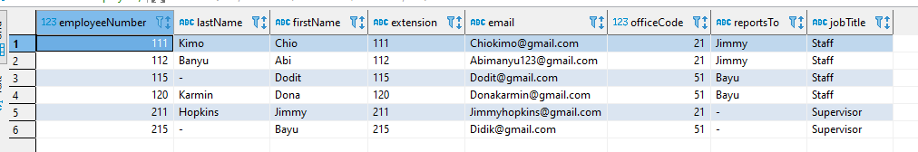

Soal 8

**SELECT** * **FROM** offices;

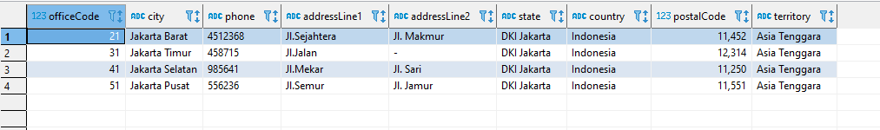

Modif 1 (select table dengan where)

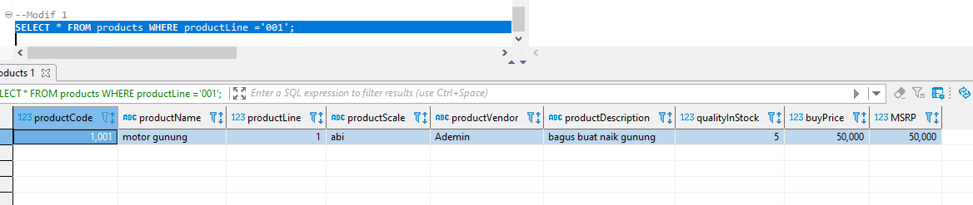

Modif 2 (join table)

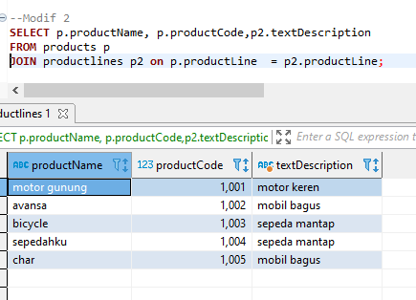

Modif 3 (join table dengan where dan order)

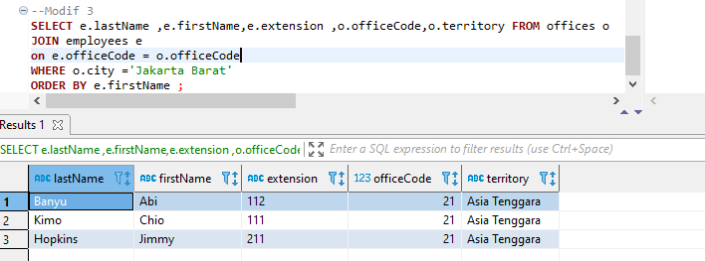

Modif 4 (union table)

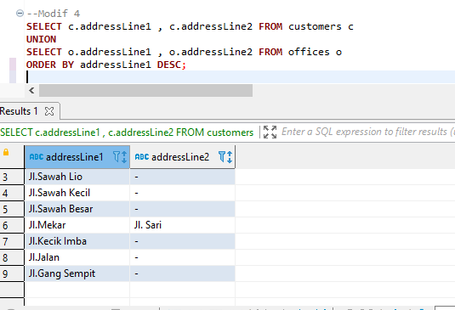

Modif 5 (join table lebih dari 1)

